

|  |
| --- |
| MTN.BI.07 Introduction to Data Warehousing  Introduction to Data Warehousing |
| Laboratory work |

Contents

1. Virtual machine setting 3

2. GIT 7

3. CHOOSE BUSINESS FOR YOUR PROJECT 11

# 1. Virtual machine setting

1. Import VM “BI 2018.ova”.

*VM has been imported:*

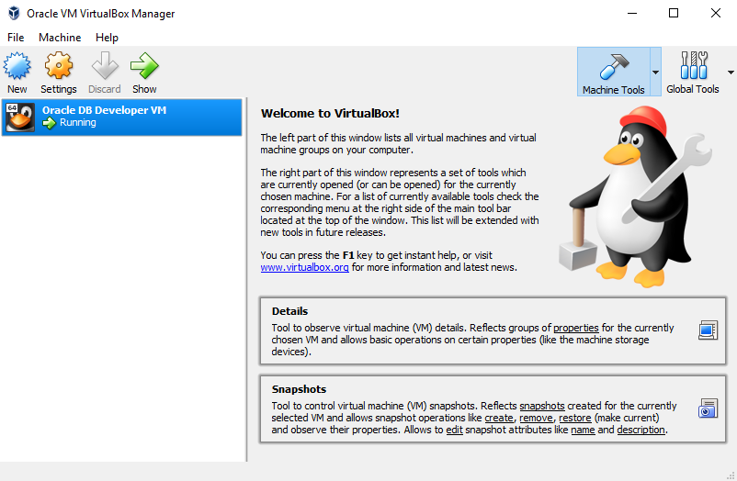

1. Set shared folder between your windows machine and remote machine (this folder might be your GIT folder)

*Shared folder has been set:*

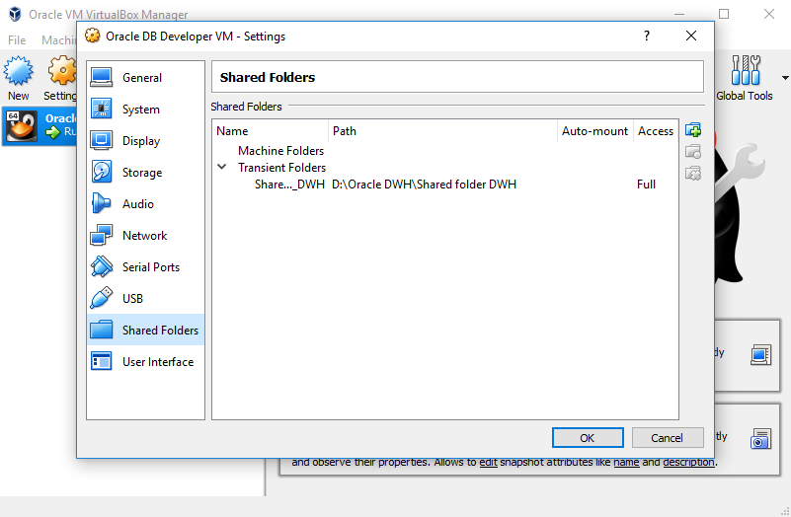

1. Connect to Oracle using sqldeveloper from your Windows machine (port forwarding in your virtual machine needs to be enabled)

*Connection to the virtual machine has been made:*

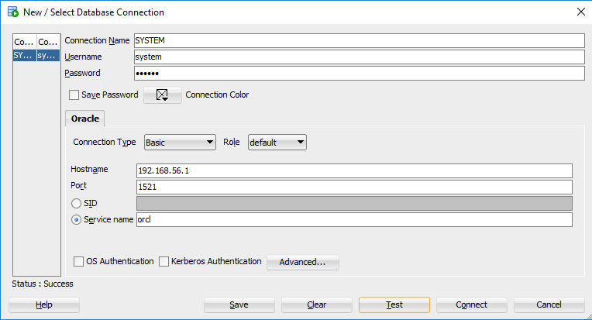

1. Create your user/schema (in Oracle) test_user – try new VM

*User test_user has been created,*

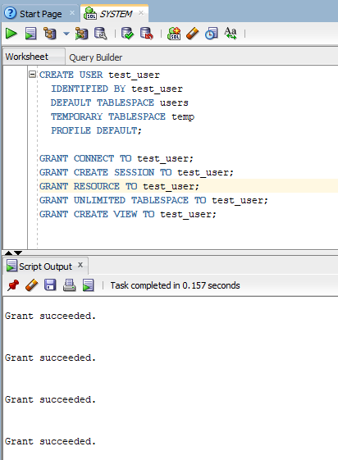

*connection has been tested:*

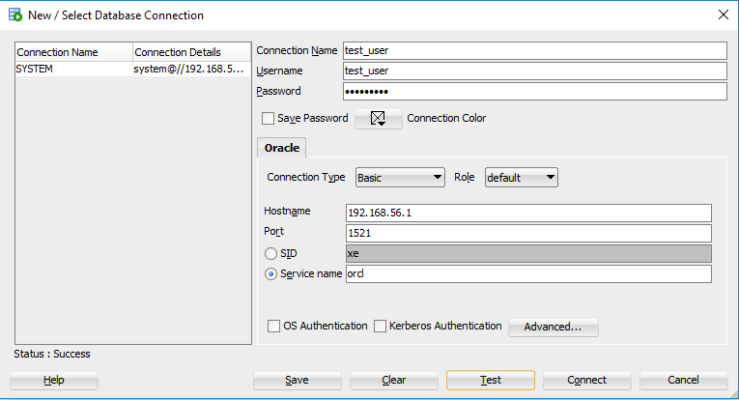

*Created user can be successfully drop from VM (using system – localhost – 1521 – orcl – oracle connection):*

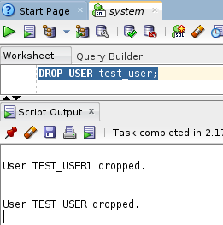

# 2. GIT

1. Pass GIT tutorial <https://githowto.com/>
2. Clone our “BI_Lab_winter-spring_2018” repository

Repository

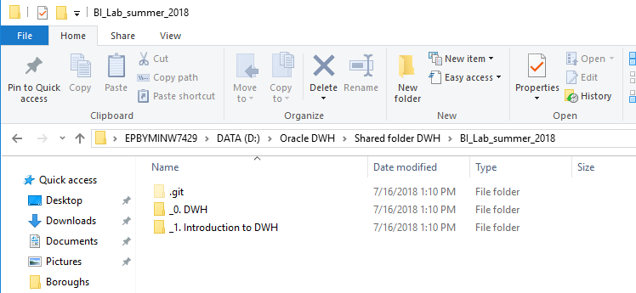

1. Add, commit and pull your personal folders to “BI_Lab_winter-spring_2018\_0. DWH\Project\” and “BI_Lab_winter-spring_2018\_1. Introduction to DWH\Tasks”, use “Name_Surname” template.

*After cloning repository and creating new folders we pull personal folders back to github:*

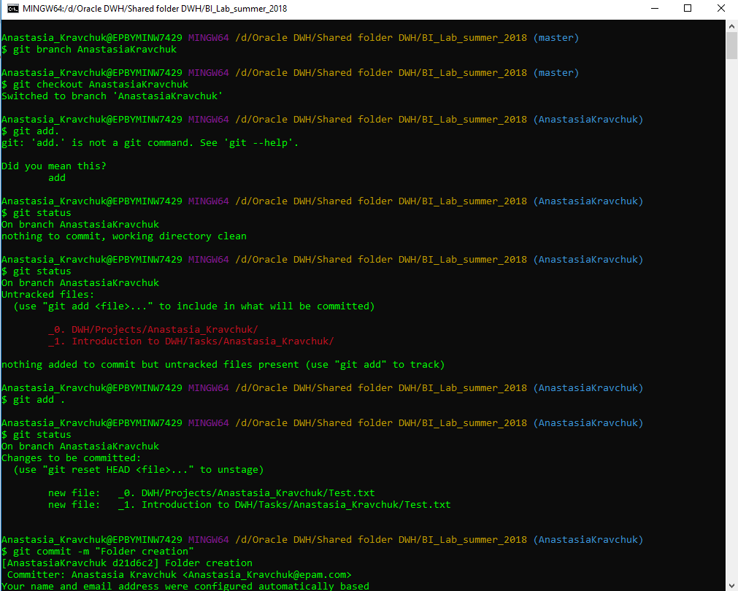

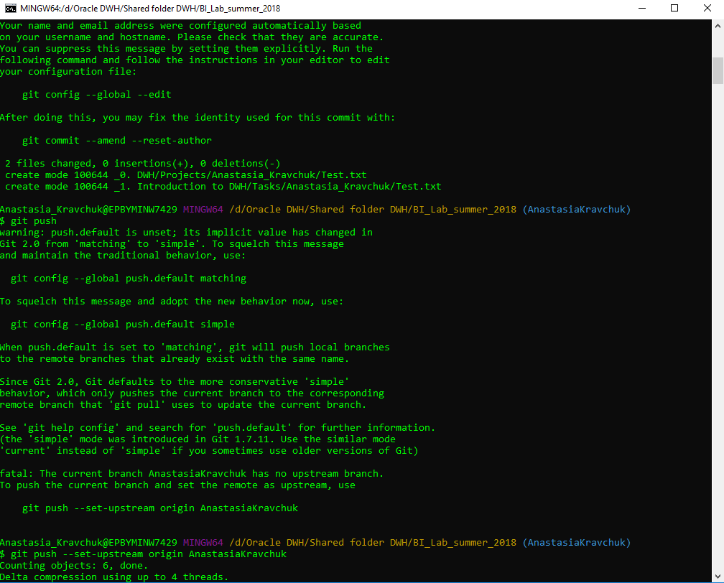

*The final result is the following:*

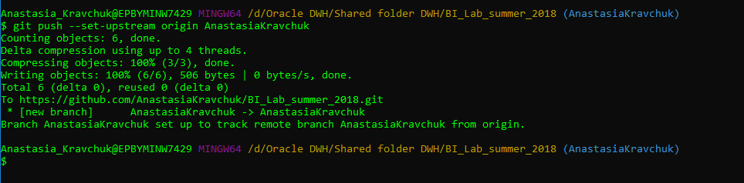

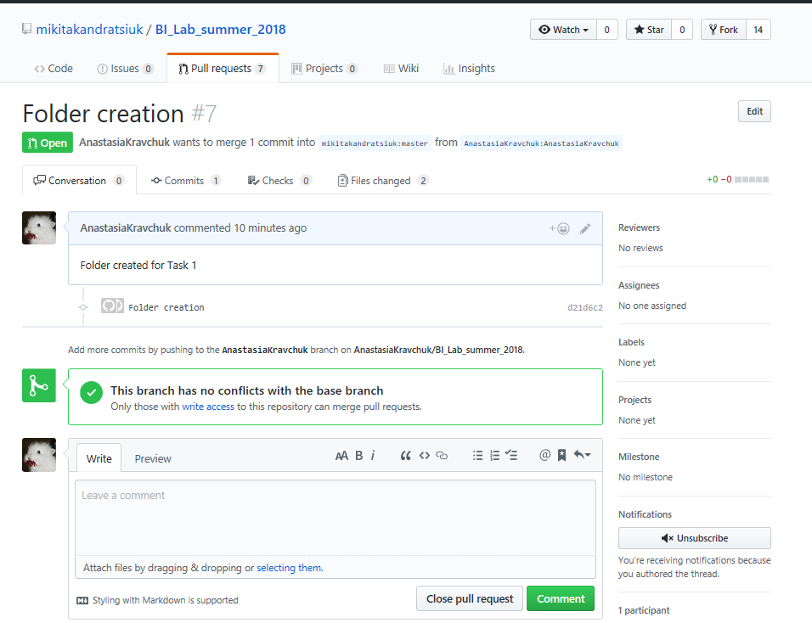

# 3. CHOOSE BUSINESS FOR YOUR PROJECT

* For the next lessons you’ll be creating document describing your chosen business and creating plan of implementing data warehousing for this business.
* During the ETL module you will implement DWH and ETL according to your plan.